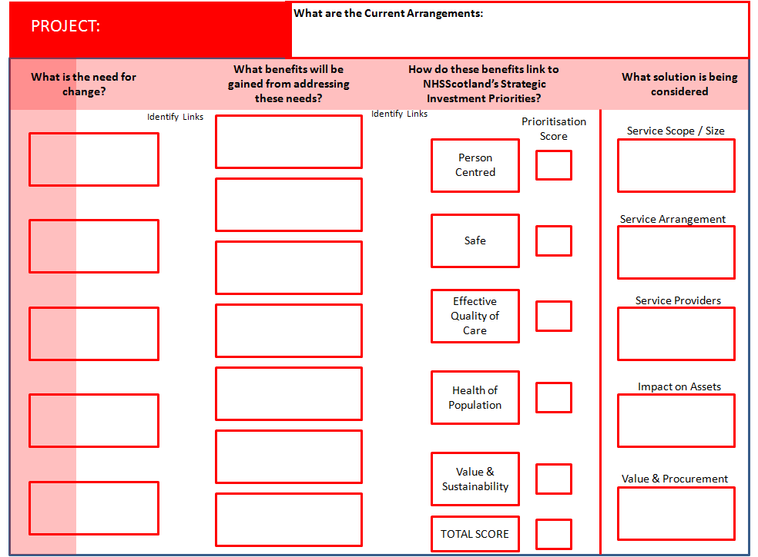
¹Primary and community health and care services are limited in an identified area of high deprivation

Integrated and comprehensive patient care and treatment for the residents of Lochgelly is severely compromised by a facility that is not fit for purpose
²Patients are required to make repeated visits for care due to limited collaborative working
³Emerging integrated models of care undeliverable in current environment
⁴Premises are functionally inadequate and compromise pro-active patient care
⁵Physical characteristics of building and inadequate infrastructure prevents safe and effective patient care: below HAI standards
^{a)}Services developed in partnership for all patients including complex needs
^{b)}Improve patient safety and reduce risk
^{d)}A community asset based model that promotes self management & wellbeing
^{f)}Improved financial performance

^{c)}Improve anticipatory and preventative care for patients
^{g)}Significantly improves functional suitability of the healthcare estate
^{e)}Promotes a professional and cohesive working environment with integrated systems

Fuller range of primary and community health and care services
Integration of health and social care services and co-location of supporting services provided locally
Existing GPs, NHS staff, integrated health & social care and voluntary service providers
Potential new and enhanced facility
Hub – value circa
£5-6million
V0.6 – Last updated 11.03.2016
LOCHGELLY
5
5
4
4
5
91

The Strategic Assessment Workshop had 14 attendees –

The Working Group recognises that wider involvement from departments and organisations including the third sector will be crucial as this work is progressed.

Dr. Cattanach, GP
Lorraine Cooper King, Business Manager
Patricia Cunningham, Fife Council
Charlene Davidson, Practice Manager
Elaine Duncan, Business Manager
Michele Eason, Practice Manager
Lesley Eydmann, Localities Manager
Darren Karrim, Nursing Team Leader
Julie Parkinson, Head of Primary Care Administration
Jim Rotheram, Acting Head of Estates and Facilities
Dr. Thomson, GP
Elaine Stark, Practice Nurse
Dr. Waugh, GP
Dr. Wilson, GP

Lesley Eydmann
Localities Manager
7 December 2015

NB Scoring carried out 17 02 2016 by Lesley Eydmann, Jim Rotherham and Scott Baillie based on meeting outcome notes.

